# **SSL Steps**

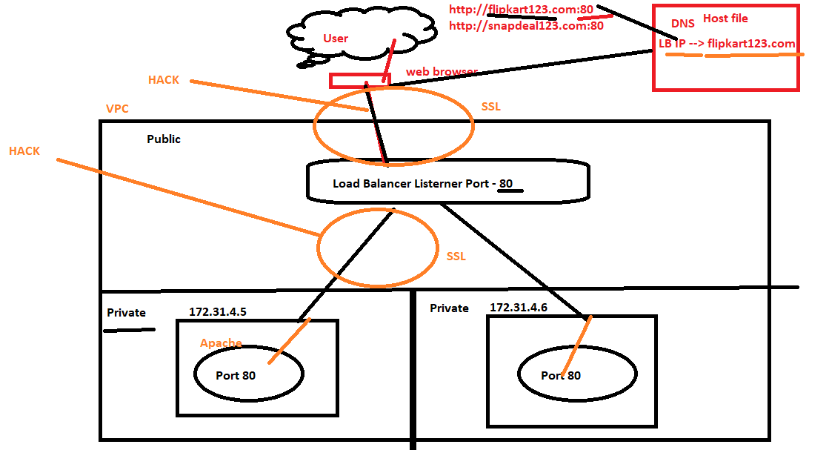

# Create a **self-signed certificate – More steps than Certified Authority**

## Pre-req –

Check if your Apache is pre-installed ?

[root@ip-172-31-39-40 ~]# httpd -v

Server version: Apache/2.4.37 (Red Hat Enterprise Linux)

Server built: Jan 27 2021 07:22:47

## **yum install mod_ssl openssl -y**

### **mod_ssl** – this is used to configure Apache with SSL

### **openssl** – is for creating SSL Certificate

## Create a Key

cd /etc/httpd ## APACHE_HOME

mkdir ssl

cd ssl

### openssl genrsa -out awsclass123.key 2048

[root@ip-172-31-34-211 ssl]# openssl genrsa -out awsclass.key 2048

Generating RSA private key, 2048 bit long modulus

.......+++

.+++

e is 65537 (0x10001)

## **Create a Certificate Request - CSR**

### **openssl** req -new -key awsclass.key -out awsclass.csr

You are about to be asked to enter information that will be incorporated

into your certificate request.

What you are about to enter is what is called a Distinguished Name or a DN.

There are quite a few fields but you can leave some blank

For some fields there will be a default value,

If you enter '.', the field will be left blank.

-----

Country Name (2 letter code) [XX]:IN

State or Province Name (full name) []:Hyd

Locality Name (eg, city) [Default City]:miyapur

Organization Name (eg, company) [Default Company Ltd]:lwplabs

Organizational Unit Name (eg, section) []:training

Common Name (eg, your name or your server's hostname) []:awsclass123.com

Email Address []:mailrahulsre@gmail.com

Please enter the following 'extra' attributes

to be sent with your certificate request

A challenge password []:

An optional company name []:

You can now pass on the **CSR** to Certificate Authority and they will give you below 3 files –

I’ll raise a ticket to SSL team, who will send a mail to Digicert Certificate Authority to give me below 3 files –

[root@ip-172-31-38-150 ssl]#

Custom singed certificate – **Digicert/Verisign will give** you

**USERTrustRSAAddTrustCA.CCC**

**TrustedSecureCertificateAuthority5.ccc**

**302880581.ccc** - This name will change for every request - Server certificate

SSLCertificateFile /etc/ssl/certificate.crt

SSLCertificateKeyFile /etc/ssl/private/private.key

SSLCertificateChainFile /etc/ssl/ca_bundle.crt

## **Create self signed Certificate**

openssl **x509** -req -days 365 -in awsclass.csr -signkey awsclass.key -out awsclass.crt

Signature ok

subject=/C=IN/ST=Hyd/L=miyapur/O=gyanvriksh/OU=training/CN=awsclass123.com/emailAddress=mailrahulsre@gmail.com

Getting Private key

### Validate the certificate -

[root@ip-172-31-86-220 ssl]# openssl x509 -in awsclass.crt -text -noout

Certificate:

Data:

Version: 1 (0x0)

Serial Number:

b4:c2:d4:bd:11:bc:fa:f3

Signature Algorithm: sha256WithRSAEncryption

Issuer: C=IN, ST=Hyd, L=Kondapur, O=Gyanvriksh, OU=Training, CN=flipkart123.com/emailAddress=mailrahulsre@gmail.com

Validity

Not Before: Apr 5 05:42:18 2020 GMT

Not After : Apr 5 05:42:18 2021 GMT

### Edit ssl.conf

Go to directory – **/etc/httpd/conf.d**

1. edit ssl.conf and edit the SSL certificate path where we have created the crt and key file
2. Change **ServerName parameter** to **our** **Common Name** which we gave earlier while creating the csr file above.
3. DocumentRoot "/var/www/html/aws"
4. Save it

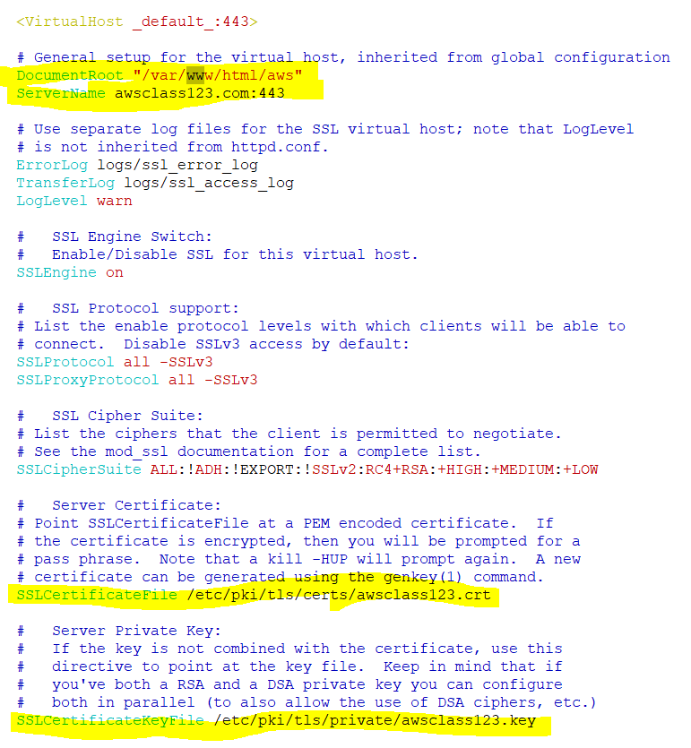

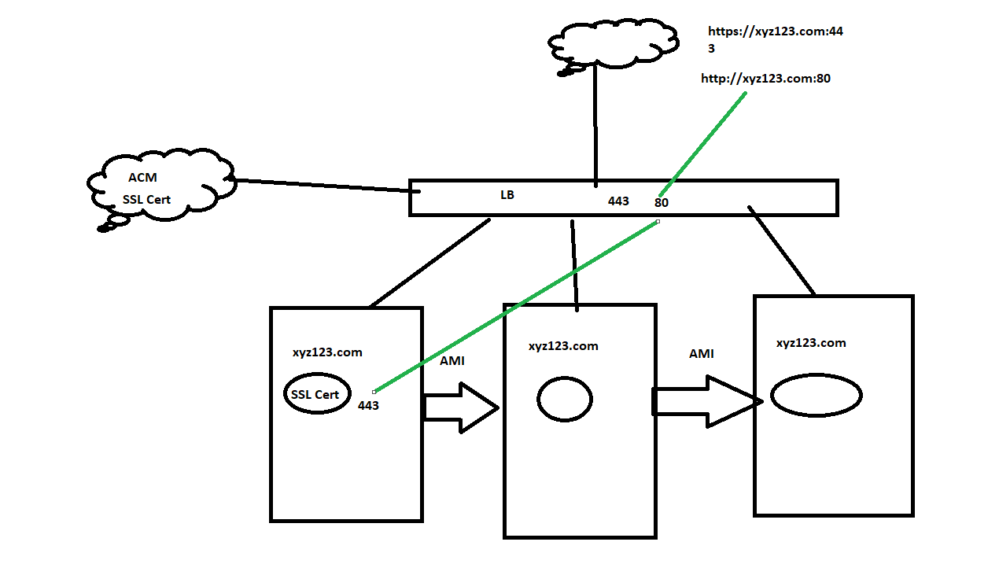

### Upload key and crt in **AWS ACM**

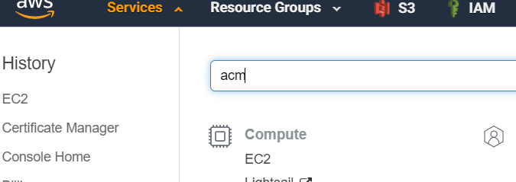

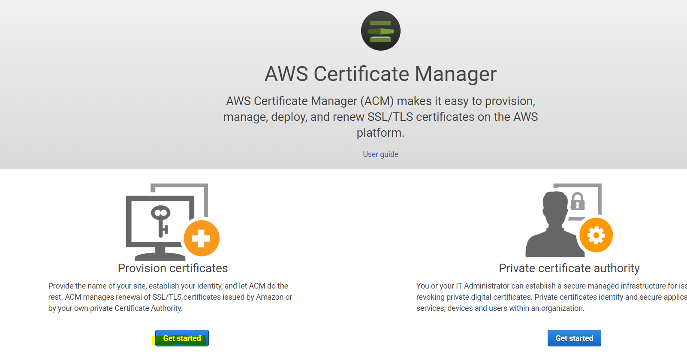

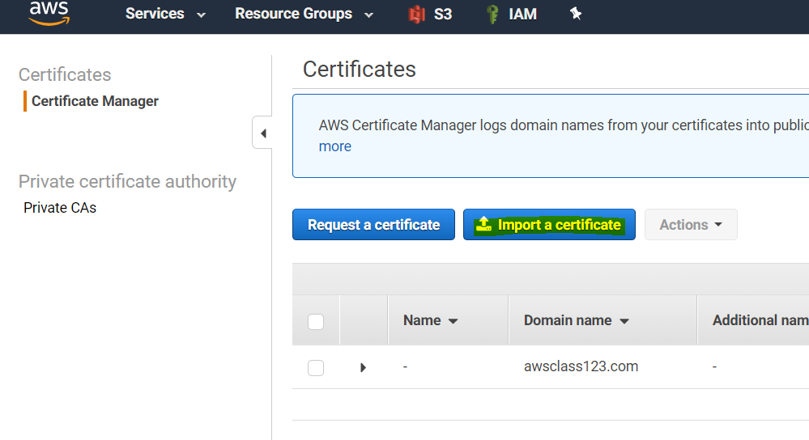

**Custom singed certificate**

USERTrustRSAAddTrustCA.CCC

TrustedSecureCertificateAuthority5.ccc

302880581.ccc - Copy this Certificate Body below

Certificate chain will be updated with all the certificates above

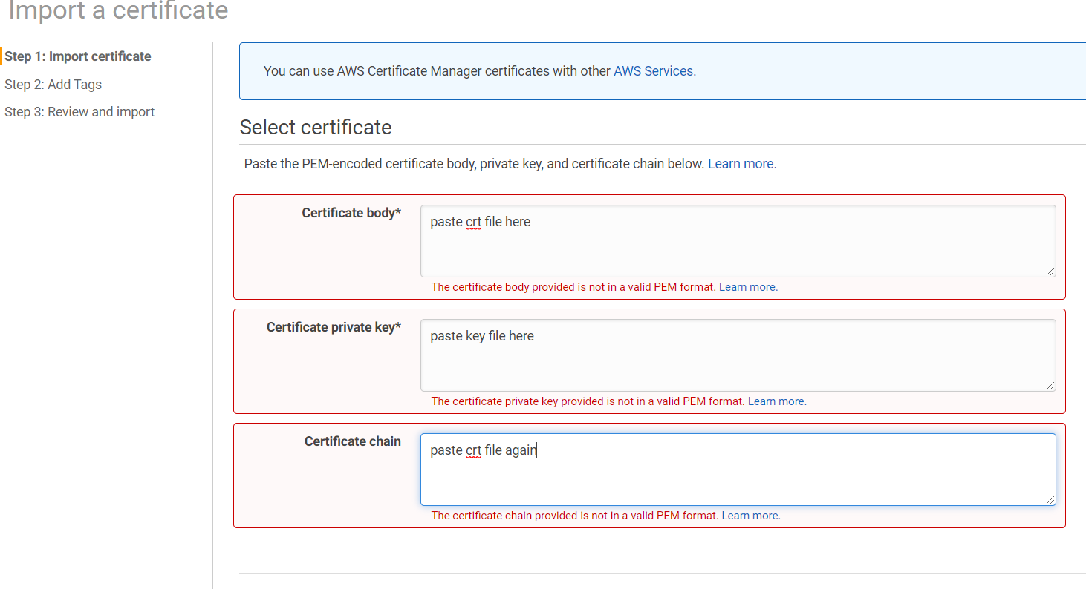

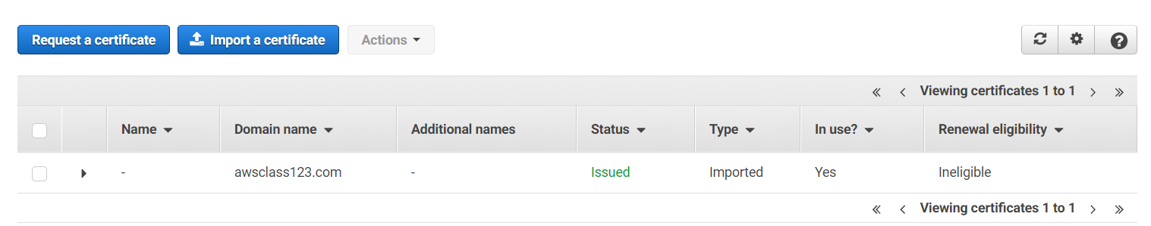

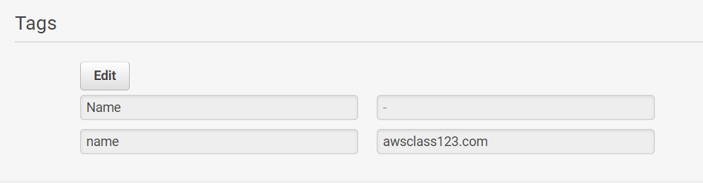

### Attach the SSL certificate in the Load Balancer which we are using

1. Edit the security group so that it can listen 443 port which is default port of SSL in https
2. Edit the listener section to below and point to the new ACM which we have done now

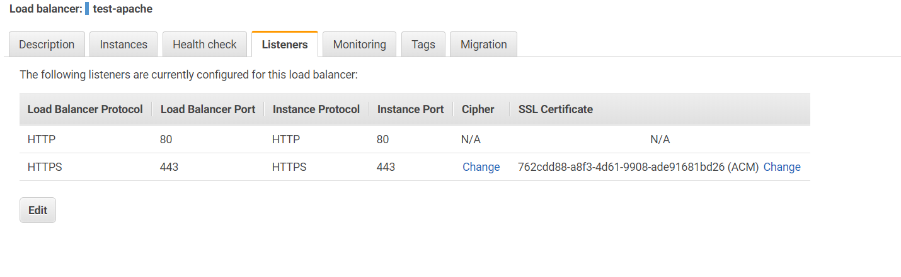

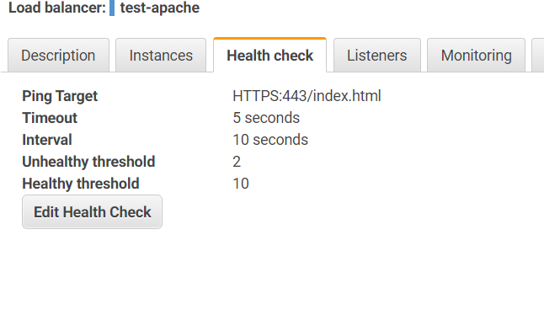

# AWS Application Load Balancer